**CSE 212 – Programming with Data Structures**

**W01 Prove – Response Document**

|  |  |
| --- | --- |
| **Name:** | Daen Antule |
| **Date:** | April 22, 2023 |
| **Teacher:** | Bro. Kunz |

*It is a violation of BYU-Idaho Honor Code to post or share this document with others or to post it online. Storage into a personal and private repository (e.g. private GitHub repository, unshared Google Drive folder) is acceptable.*

**Question 1: For the rotate right problem, provide a description of how you solved the problem.**

**MY PLAN:**

1. Determine the number of elements to be rotated to the right. Since the value of the amount will be in the range of 1 and len(data), I can determine the number of elements to be rotated by calculating len(data) - amount. For example, if the length of the list is 9 and the amount is 5, I need to rotate 4 elements to the right (9 - 5 = 4).
2. Slice the list into two parts. The first part will contain the last n elements (where n is the number of elements to be rotated), and the second part will contain the remaining elements.
3. Concatenate the first and second parts of the list in reverse order to obtain the rotated list.

**MY PROCESS:**

First, I split the original list into two parts:

The left part contains everything before the index 'len(data)-amount'. For example, if the original list is '[1, 2, 3, 4, 5, 6, 7, 8, 9]' and I want to rotate it to the right by an amount of '5', then the left part will contain '[1, 2, 3, 4]'.

The right part contains everything from the index 'len(data)-amount' to the end. In our example, the right part will contain '[5, 6, 7, 8, 9]'.

Next, I reverse both parts. In our example, the left part becomes '[4, 3, 2, 1]' and the right part becomes '[9, 8, 7, 6, 5]'.

I concatenate the two reversed parts to create a new list. In our example, the concatenated list becomes '[4, 3, 2, 1, 9, 8, 7, 6, 5]'.

Finally, I reverse the entire list to get the final result. In our example, the final list is '[5, 6, 7, 8, 9, 1, 2, 3, 4]'.

**Question 2: For the rotate right problem, draw a picture of how you solved the problem.**

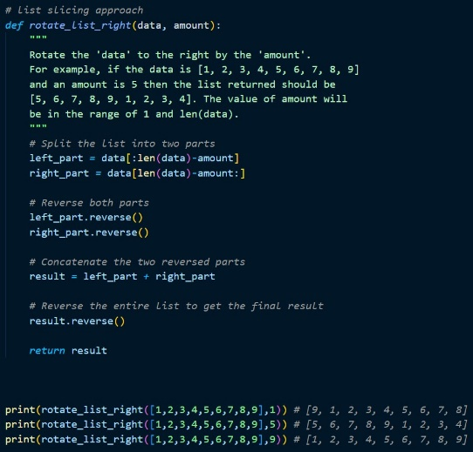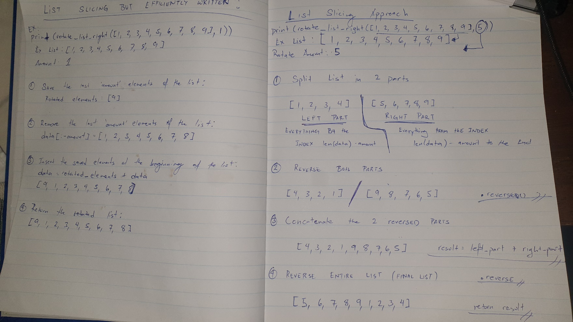

Remember: You need to submit the following code files in addition to this document:

* 01-prove_multiples_of.py
* 01-prove_rotate_list_right.py